Jain Convocation Portal

https://github.com/jeryjs/Jain-Convocation-Portal

Overview

Introduction
The Jain Convocation Portal is a web application developed for managing convocation images for Jain University during its 14th convocation. It is designed to handle high traffic during the convocation ceremonies and is built with a focus on efficiency, scalability, and ease-of-maintenance. The portal features a separation of concerns by maintaining a dedicated backend and frontend, ensuring that each part can be independently developed and scaled.

Purpose
The primary purpose of this project is to allow the management, display, and request of convocation photographs. It serves multiple user roles, including regular users and administrators.
- For regular users: The portal offers a user-friendly interface to view and request image softcopies or hardcopies.
- For administrators: It provides tools to manage user requests, configure event settings, and handle the storage and distribution of photos.
- Event scalability: Designed to support a large number of simultaneous requests during major convocation events, ensuring the system's responsiveness and reliability.

Dependencies
- Backend
  - Express.js: A robust framework for building RESTful API endpoints for the backend.
  - nodemon: Used during development to automatically restart the server on code changes.
  - dotenv: Allows the management of configuration and secret keys through environment variables.
  - Firebase Admin: Facilitates interaction with Firebase services, particularly for authenticating and managing users.
  - Google APIs and Multer: Utilized for file handling and integration of third-party services.
  - Nodemailer: Sends mail notifications, crucial for account setups and confirmations.
- Frontend
  - React: The core library used for building the dynamic and responsive user interface.
  - Vite: A fast and modern development tooling that serves the React application during development.
  - Material UI (MUI): Provides a set of React components that implement Google's Material Design, ensuring a consistent and polished look for the application.
  - React Router DOM: Facilitates seamless client-side routing between different views and screens within the application.
  - Utility Libraries: Framer-motion for animations and qrcode.react for QR code generation.
- Development and Build Tools
  - Concurrently: Runs the frontend and backend processes simultaneously during development.
  - ESLint: Enforces consistent coding styles and best practices across the project.
  - TailwindCSS: Combined to allow utility-first styling and efficient CSS processing on the frontend.
- Deployment and Configuration
  - Vercel: The application is configured for deployment on Vercel, ensuring automated builds and continuous deployment directly from the GitHub repository.

Working

Screens
1. Home Screen
Overview
The Home Screen serves as the gateway to the application. It acts as a framework for holding information about the convocation event, recent announcements, and quick links to login or register. It is built using React components combined with Material UI (MUI) for a clean, responsive layout.
Functionality & Components
- Header & Navigation:
A fixed header contains navigation links managed by React Router DOM. These links help users navigate between public pages (like event details) and secure areas such as the account dashboard.
- Dynamic Content Sections:
The main area is divided into sections that dynamically load information such as event highlights, featured images from past convocations, and call-to-action buttons. This content is fetched from the Express backend using predefined API endpoints.
- Responsiveness:
CSS media queries along with MUI’s responsive components ensure that the Home Screen adapts seamlessly on desktops, tablets, and mobile devices.
- Call-to-Action Buttons:
Buttons are styled with CSS-in-JS (MUI’s sx prop) or TailwindCSS classes. They include hover and focus states inspired by the styling rules in index.css.

2. Authentication & Login Screen
Overview
The Login Screen manages user authentication. It integrates secure storage operations so that user credentials, tokens, and session data are safely persisted across sessions.
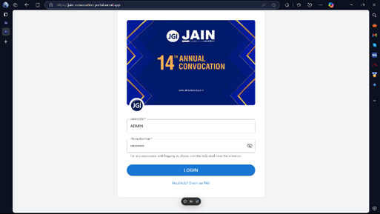
Functionality & Components
- Form Handling:
The login form takes in user credentials (username and password) and submits them via async API calls to the Express backend. Successful authentication returns a token that is stored locally.
- AuthContext Integration:
Managed within AuthContext.jsx, the AuthProvider uses hooks such as useState and useEffect to both initialize and persist authentication-related state. Functions like login and logout execute the core logic for state updates and secure storage operations.
  - When the state changes, the secure storage mechanism is updated to ensure that the user’s session persists even after a page refresh.
- Error Handling & Feedback:
Real-time feedback appears on the screen using MUI’s Snackbar component. This provides users with immediate notification on authentication success or failure.
- Security Measures:
The authentication flow ensures that sensitive data is cleared when no longer needed, and tokens are validated on each protected route, creating a robust mechanism against unauthorized access.

3. Courses Screen & Image Gallery
Overview
After logging in, regular users are directed to the courses page. This page displays the various available sessions from where they are taken to an image gallery along with options to select images, request soft or hard copies, and view status updates.
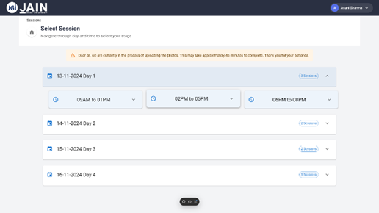
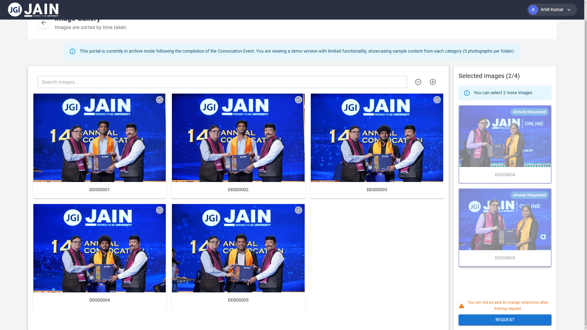
Functionality & Components
- Dynamic Image Gallery:
The gallery is implemented using a combination of React state management and MUI’s grid components. Images are loaded from the backend storage (integrated with systems like OneDrive) and displayed in an organized, responsive grid.
- Image Selection & Requests:
Users can click on images to mark them for request. The selection state is managed through context and persisted in secure storage. Each image card displays details and interactive buttons to initiate a request.
- Backend Integration:
API calls retrieve image metadata and availability information. The backend, written with Express, ensures the images are served efficiently even under high load. This efficiency is achieved by caching configurations (see the initializeSettings function in index.js) and deep merging settings from various sources.
- User Feedback:
Interaction feedback is given via visual cues on the image tiles and through Snackbar messages informing users of request success or errors.

4. Request Screen
Overview
The Requests Page is designed to facilitate the submission and tracking of image requests by users. Each component on this page serves a clear purpose to ensure that the request process is smooth and transparent.
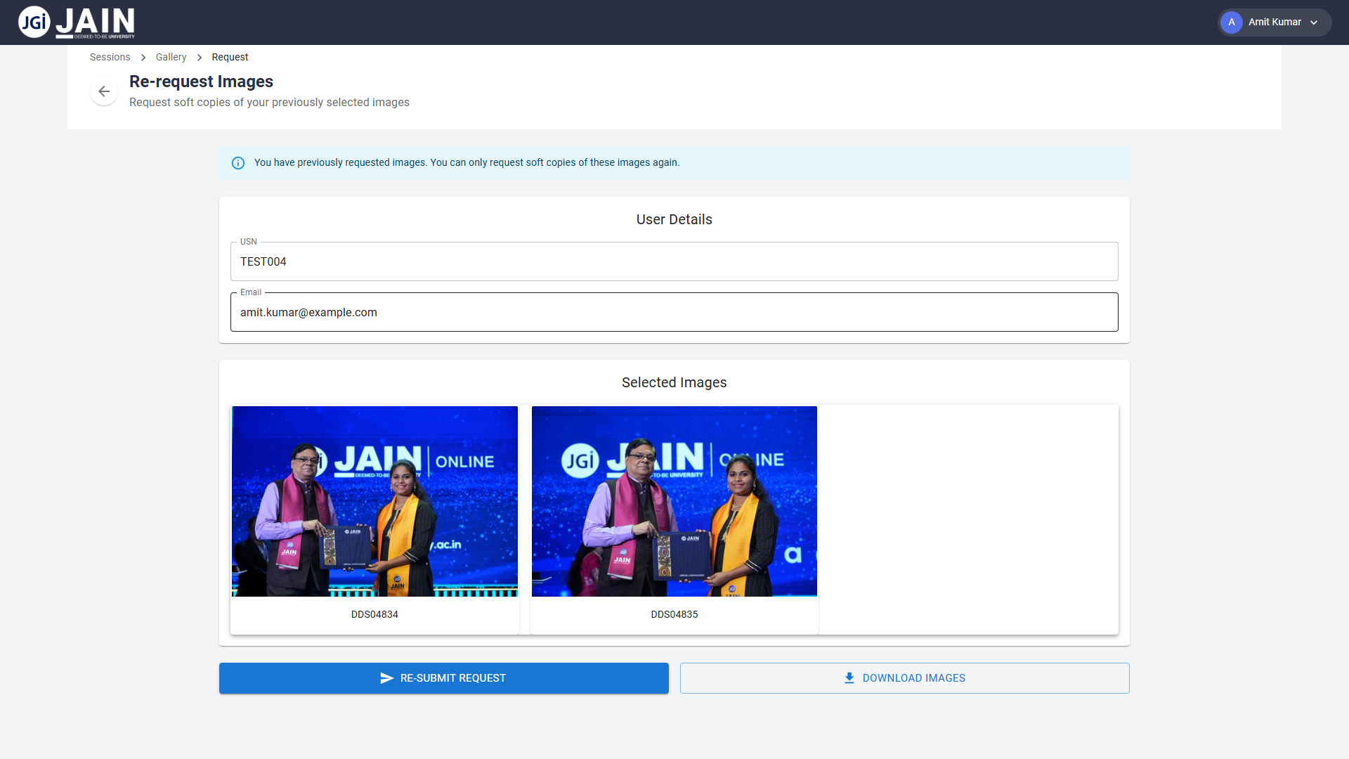
- Request Form & Image Selection:
Users can easily select images from the gallery and add them to their request form. The form guides users on specifying whether they require soft or hard copies, ensuring clarity in each request.
- Real-Time Updates & Status Indicators:
Once a request is submitted, the page provides real-time feedback on its status. This includes visual cues and text messages that inform users if their request is pending, approved, or in process. Immediate status updates help maintain user confidence and reduce uncertainty.
- Backend Integration & Error Handling:
Each request triggers an API call to the backend, where validations and processing occur. Errors during submission are caught promptly and relayed to the user, ensuring that misconfigurations or network issues are quickly addressed for a seamless experience.
5. Admin Dashboard & Settings Screen
Overview
This section combines administration functionalities with the configuration management process into one unified dashboard, providing a single interface for critical system updates. Every element here is purposefully designed and integrated to ensure that configurations are accurate, changes are immediately reflected, and overall system stability is maintained.
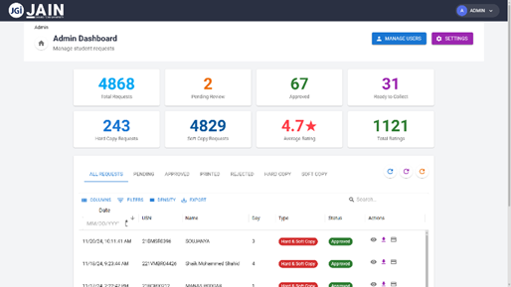
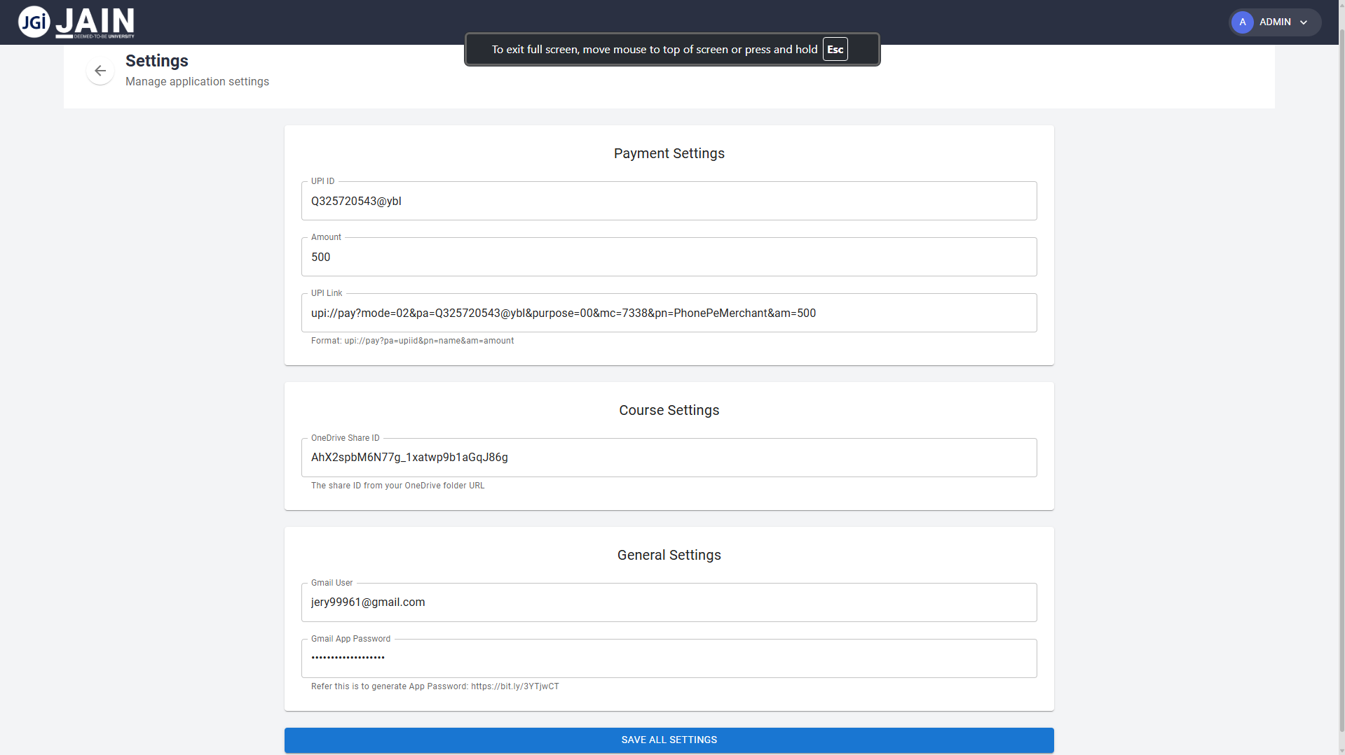
Functionality & Components
- Configuration Panels:
The dashboard features distinct panels for various settings such as Gmail credentials, OneDrive Share IDs, and course-specific configurations. Each panel includes input fields with clear helper text that explains the expected format and purpose. This minimizes input errors by guiding administrators on what each value does and why it is needed. By explicitly specifying items like app passwords or sharing IDs, the interface reduces misconfigurations that could impede system operations.
- Real-Time Data Synchronization:
When administrators make changes, the dashboard's real-time data binding immediately reflects those updates across the system. This feature ensures that modifications are consistently applied to both the front-end view and the back-end cache without a need to manually refresh or restart the application. The immediate update of settings provides confidence that changes are effective and minimizes downtime during critical operations.
- Server-Side Validation and Caching:
Every configuration change is validated on the backend to ensure proper formatting and completeness. Additionally, the system employs a caching mechanism that uses deep merging techniques to integrate new settings with existing ones seamlessly. This not only prevents accidental data loss but also maintains the integrity of previously established configurations. The automatic validation prevents the application from entering an unstable state due to improper configuration values.
- Submission and Feedback Mechanism:
A clear "Save All Settings" action triggers the process of sending updated configurations to the server. Upon submission, data is both saved to a persistent storage and updated in the in-memory cache. The administrators receive feedback—via a Snackbar notification—indicating the success or failure of their changes. This immediate response aids in troubleshooting by highlighting issues as soon as they occur.
- Consistent Error Handling and Logging:
The integrated error logging mechanism captures and displays any issues encountered during the configuration update process. If an administrator inputs an invalid value or leaves a required field empty, the system immediately notifies them and logs the error for further analysis. This ensures that stability is maintained by preventing improper updates and providing clear insights into what went wrong, thus allowing administrators to quickly correct any issues.

6. Workflow & Mechanisms
- Integrated Front-End and Back-End Workflows:
The application uses RESTful APIs to connect the React front-end to the Express back-end. Every interaction—whether it’s a configuration change in the admin dashboard, a request submission by a user, or fetching image data—is handled via clear API endpoints. This separation of concerns ensures that data processing, validation, and business logic remain in the back-end while the front-end focuses on delivering a responsive, interactive user experience.
- Caching Mechanisms and Data Synchronization:
To optimize performance and minimize redundant API calls, caching is implemented on the server side. When configurations or commonly requested data (like image metadata) are fetched, they’re stored in an in-memory cache. This cache is updated using a deep merging strategy whenever settings change, ensuring that both the front-end and back-end have consistent and up-to-date information without the overhead of constant database reads.
- Robust Workflow and Error Handling:
Both the admin dashboard and the requests page feature comprehensive error handling protocols. For instance, any failed validation on the back-end—whether due to misconfiguration or data format issues—triggers immediate notifications in the front-end UI, allowing for on-the-spot corrections. The real-time feedback facilitates a fluid workflow where front-end components continuously poll the back-end status, ensuring that users have the latest data and that administrative settings are applied without delay.
- Unified Data Flow Management:
The architecture emphasizes a unified flow of data by integrating authentication, settings management, and user requests into a coherent sequence. This includes:
  - Initial settings being loaded and cached during application startup.
  - Real-time synchronization when administrators adjust configurations.
  - Efficient propagation of data changes (via API calls) to the user interface components.
This seamless data flow between the UI and the server minimizes inconsistencies and improves overall responsiveness.

Performance and Scalability
This section dives into the mechanisms that ensure the Jain Convocation Portal handles high traffic and extensive data loads without compromising performance. The application employs several strategies to maintain responsiveness and stability amid sudden surges in user activity.
- Optimized API Calls and Caching:
The backend, built with Express.js, leverages in-memory caching to store frequently accessed configurations and image metadata. For example, the settings initialized in the initializeSettings() function are deep merged and cached, ensuring that subsequent API calls do not repeatedly fetch identical data from slower persistent storage systems. On the front-end, pages like the CoursesPage utilize a dedicated cache manager to reduce redundant fetch requests, enhancing page load times and reducing server load during peak hours.
- Efficient Data Handling and Compression:
With data exchanges often involving base64 encoded images or larger JSON payloads, both the front-end and the back-end enforce strict size limits (e.g., setting JSON payload limits to 500KB). These controls prevent performance bottlenecks related to bandwidth consumption and ensure that data remains within manageable bounds throughout transmission.
- Load Distribution and Concurrent Processing:
The design of the application takes advantage of modern Node.js practices, using middlewares such as cors and body-parser to efficiently handle concurrent requests. By distributing the workload and incorporating asynchronous functions for data retrieval and processing, the system maintains low latency even when multiple users access image galleries or submit requests simultaneously.
- Scalability through Modular Architecture:
A modular architecture underpins the platform, separating concerns across distinct route handlers (e.g., userRoutes, courseRoutes, requestRoutes, adminRoutes, and emailRoutes). This design not only aids in maintainability, but it also allows individual modules to be scaled independently. If one module experiences heavy load—say, during peak image request times—it can be optimized or deployed separately without affecting overall system performance.
- Monitoring and Performance Feedback:
System logs and real-time notifications, such as those within the CoursesPage and admin modules, provide administrators with critical performance insights. By monitoring response times, caching hits, and error rates, the portal’s administration team can quickly identify and remedy performance bottlenecks. This proactive approach ensures smooth user experiences even under strenuous conditions.
Overall, the performance and scalability strategies implemented in the Jain Convocation Portal guarantee that the user interface remains responsive, the backend operations remain efficient, and resources are optimally allocated during both regular hours and peak usage periods.

Security and Compliance
Security is a foundational aspect of the portal's design. This section outlines how the application ensures data integrity, user privacy, and adherence to industry standards and license compliance.
- Robust Authentication and Secure Communication:
User authentication is implemented using secure storage protocols on both the front-end and back-end. The login processes are fortified by validating tokens on each protected route. Sensitive data—including user credentials and session tokens—is handled with care, ensuring that unauthorized access is prevented. All communication between the client and server is performed over secure protocols, ensuring data is encrypted in transit.
- Environment Variables and Credential Management:
The use of environment variables through the dotenv package limits exposure of critical configuration data like Gmail credentials and OneDrive IDs. These sensitive details are not hard-coded and are instead kept in controlled environments, mitigating the risk of credential leaks. The administration dashboard reinforces this by checking for required environmental variables before accepting configuration changes and by updating the cache accordingly to avoid discrepancies between runtime and stored settings.
- Input Sanitization and API Endpoint Security:
Every API endpoint, such as those handling course data or image requests, includes input validation and sanitization to prevent injection attacks. The server-side code in route handlers first logs incoming requests, then validates the data structure before processing. This practice is crucial in preventing malicious data from compromising the application or its underlying data stores.
- Compliance with Open Source Licenses:
The project’s licensed under the free and open source AGPL-3.0 license. This ensures that any modifications or distributions of the software must also be open-sourced under the same license, promoting collaboration and transparency.
- Continuous Monitoring and Audit Trails:
To further enforce security, the application leverages logging utilities across both client and server code bases. For instance, the route handler for fetching course folders in courseRoutes.js logs both successful fetches and errors, providing an audit trail for later analysis. Such logging is pivotal in quickly identifying rule violations or potential breaches, while also serving as a key component in regular security audits.
- Compliance with Data Protection Regulations:
Given that the portal deals with personal data such as student information and image metadata, it is designed to comply with prevailing data protection regulations. Flexible policy updates allow for adjustments to meet future regulatory requirements, ensuring that user data is handled, stored, and transmitted according to legal standards.

